Testing Report

Dated
8th November 2022
Table of Contents
1 Test performed 1
2 Material used 1
2.1 Thermoplastic Rings 1
2.2 Rubber Square 2
3 Test and results 3
3.1 Dimensions testing 3
3.2 Hardness testing 4
3.3 High temperatures testing 5
3.3.1 Thermoplastic rings 5
3.3.2 Rubber squares testing. 29
3.4 Thermal properties 36

List of Figures
Figure 1: Thermoplastic rings provided by the Welltec 1
Figure 2: Rubber squares provided by the Welltec 2
Figure 3: Vernier caliper used for dimension test 3
Figure 4: Durometer used for hardness testing 4
Figure 5: Picture of thermoplastic rings samples before and after exposure to the first cycle 7
Figure 6: Picture of thermoplastic rings samples before and after exposure to the second cycle 9
Figure 7: Picture of thermoplastic rings samples after exposure to the third cycle 11
Figure 8: Picture of thermoplastic rings samples after exposure to the fourth cycle 13
Figure 9: Picture of thermoplastic rings samples after exposure to the fifth cycle 15
Figure 10: Picture of samples after the exposure to sixth cycle 17
Figure 11: Picture of samples after the exposure to seventh cycle 19
Figure 12: Dimensions comparison of sample D1867 when exposed to seven cycles of temperature testing 20
Figure 13: Dimensions comparison of sample D1868 when exposed to seven cycles of temperature testing 20
Figure 14: Dimensions comparison of sample D1869 when exposed to seven cycles of temperature testing 21
Figure 15: Dimensions comparison of sample D1870 when exposed to seven cycles of temperature testing 21
Figure 16: Dimensions comparison of sample D1872 when exposed to seven cycles of temperature testing 22
Figure 17: Samples hardness after first and second cycle of exposure at 475°F 23
Figure 18: Samples hardness after third and fourth cycle of exposure at 575°F 23
Figure 19: Samples hardness after fifth cycle of exposure at 650°F 24
Figure 20: Samples hardness after sixth and seventh cycle of exposure at 475°F 24
Figure 21: Hardness comparison of sample D1867 when exposed to seven cycles of temperature testing 25
Figure 22: Hardness comparison of sample D1868 when exposed to seven cycles of temperature testing 25
Figure 23: Hardness comparison of sample D1869 when exposed to seven cycles of temperature testing 26
Figure 24: Hardness comparison of sample D1870 when exposed to seven cycles of temperature testing 26
Figure 25: Hardness comparison of sample D1872 when exposed to seven cycles of temperature testing 27
Figure 26: Sample D1870 divided into eight sections 27
Figure 27:Dimesion measurement comparison of different sections of sample D1870 28
Figure 28: Hardness measurement comparison of different sections of sample D1870 29
Figure 29: Hardness comparison of rubber square after being exposed to 475°F for two weeks 30
Figure 30: Picture of rubber square samples after the exposure to first cycle 31
Figure 31: Severe damage to rubber square 1782/03 32
Figure 32: Broken sample 1782/03 32
Figure 33: Picture of rubber square samples after the exposure to second cycle 34
Figure 34:Comparison of wall thickness between before and after the exposure to second cycle 35
Figure 35: Comparison of rubber square perimeter between before and after the exposure to second cycle 35
Figure 36: Comparison of rubber square hardness between before and after the exposure to first and second cycle 36
Figure 37: Keithley 2400 meter with TPS-3 for the measurement of thermal properties 37
Figure 38: Comparison of thermal properties of initial and second cycle of rubber square 38
Figure 39: Comparison of effusivity of initial and second cycle of rubber square 38

List of Tables
Table 1: Comparison of the dimensions measured in the lab with the given labels provided by the Welltec 3
Table 2: Initial hardness value of thermoplastic rings 5
Table 3: Initial hardness value of rubber squares 5
Table 4: Dimension result of thermoplastic rings after the first cycle of exposure 6
Table 5: Hardness result of thermoplastic rings after the first cycle of exposure 6
Table 6: Dimension result of thermoplastic rings after the second cycle of exposure 8
Table 7: Hardness results of thermoplastic rings after the second cycle of exposure 8
Table 8: Dimension results of thermoplastic rings after the third cycle of exposure 10
Table 9: Hardness results of thermoplastic rings after the third cycle of exposure 10
Table 10: Dimension result of thermoplastic rings after the fourth cycle of exposure 12
Table 11: Hardness result of thermoplastic rings after the fourth cycle of exposure 12
Table 12: Dimension result of thermoplasticrings after the fifth cycle of exposure 14
Table 13: Hardness result of thermoplastic rings after the fifth cycle of exposure 14
Table 14: Dimension result of thermoplastic rings after the sixth cycle of exposure 16
Table 15: Hardness result of thermoplastic rings after the sixth cycle of exposure 16
Table 16: Dimension result of thermoplastic rings after the seventh cycle of exposure 18
Table 17: Hardness result of thermoplastic rings after the seventh cycle of exposure 18
Table 18: Legend description for Figures 17 to 20 22
Table 19: Section measurements of sample D1870 28
Table 20: Hardness results of rubber square sample after being exposed to 475F for two weeks 30
Table 21:Dimession results of rubber square sample after being exposed to 475°F for two weeks in second cycle 33
Table 22: Hardness results of rubber square sample after being exposed to 475°F for two weeks in second cycle 33
Table 23: Thermal properties of rubber square samples that were not exposed to high temperature condition 37
Table 24: Thermal properties of rubber square sample in which one sample was taken after second cycle test and the other one was not exposed to high temperature condition 37

Welltec testing report.

Test performed
The test conducted by the OU on the thermoplastic rings and the rubber squares provided by Welltec consisted of
- Dimension testing
- Hardness testing
- High-temperature exposure testing
- Thermal properties test
It should be noted that thermal properties test was only conducted on rubber square samples.

Material used

Thermoplastic Rings
The thermoplastic rings provided by Welltec are as follows
- D1867
- D1868
- D1869
- D1870
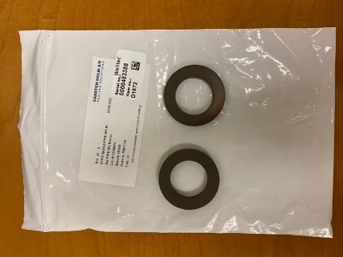
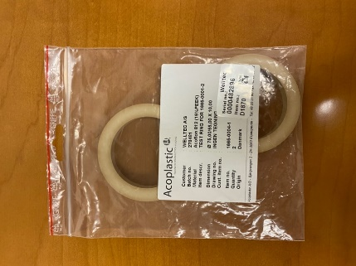
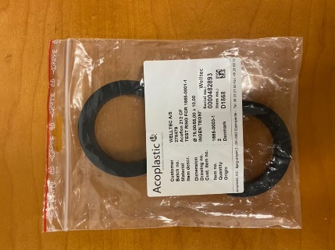
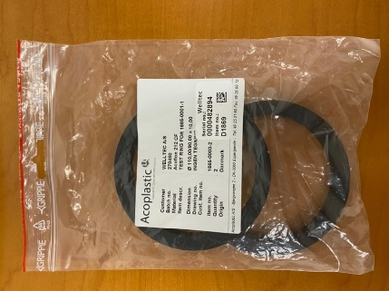
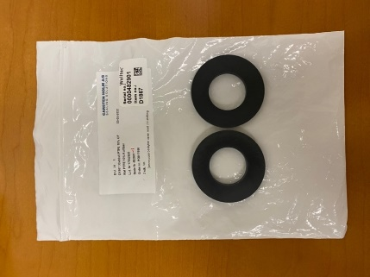
- D1872

Figure 1: Thermoplastic rings provided by the Welltec

Rubber Square
Welltec also provided forty different types of rubber squares which were divided into four different types of material, as shown in Figure 2. These four materials have been classified as follows by the Welltec:
- 1799/03
- 1787/03
- 1782/03
- 1788TH

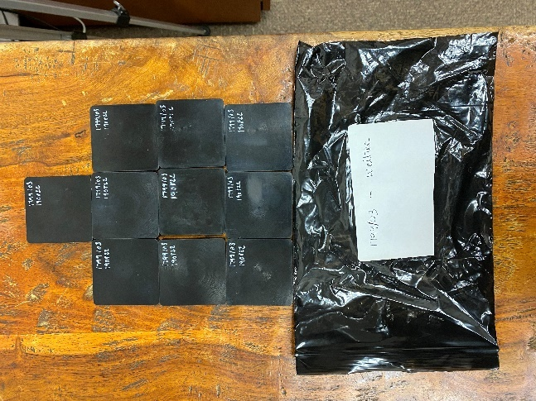
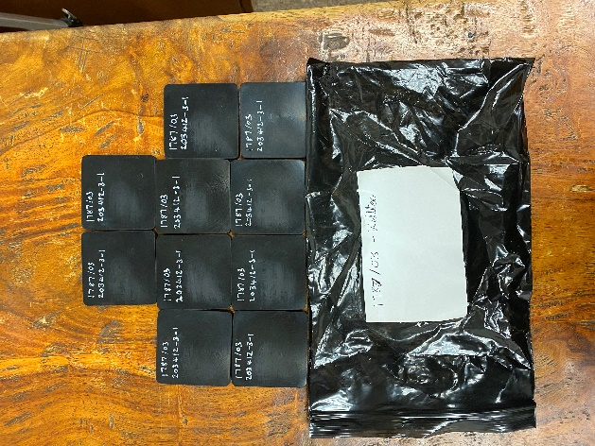
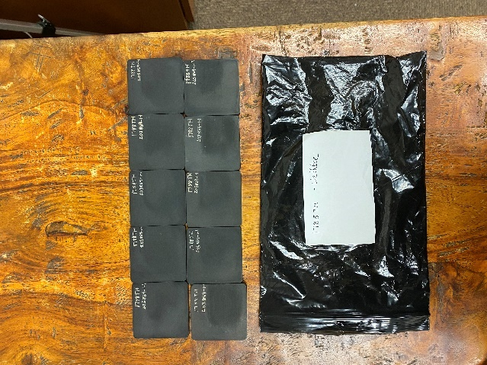

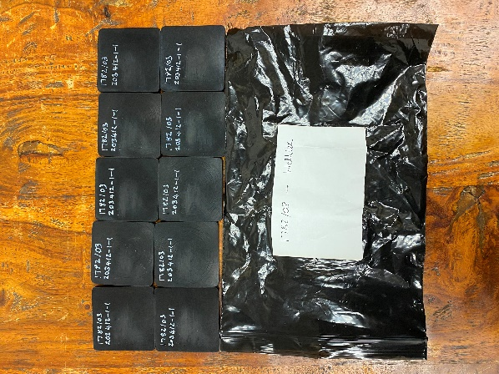

Figure 2: Rubber squares provided by the Welltec

Test and results

Dimensions testing
The purpose of doing the dimension test was to make sure that the dimensions given on the labels are the same as the dimensions measured in the lab. Moreover, a dimension test was also performed each time after the samples was exposed to the high-temperature testing that will be discussed in the following section. A standard vernier caliper (Figure 3) was used for measuring OD, ID and wall thickness (WT) of the samples.
Figure 3: Vernier caliper used for dimension test
Table 1: Comparison of the dimensions measured in the lab with the given labels provided by the Welltec
Sample No. | Labeled |  |  | Measured in lab
 | OD (mm) | ID (mm) | WT (mm) | OD (mm) | ID (mm) | WT (mm)
D1867 (1) | 60 | 30 | 5 | 59.95 | 31.02 | 4.98
D1867 (2) | 60 | 30 | 5 | 59.98 | 31.03 | 4.97
D1868 (1) | 75 | 55 | 10 | 74.96 | 55.01 | 10
D1868 (2) | 75 | 55 | 10 | 74.97 | 55.02 | 10
D1869 (1) | 110 | 90 | 10 | 109.95 | 89.99 | 10
D1869 (2) | 110 | 90 | 10 | 109.96 | 89.98 | 10.01
D1870 (1) | 75 | 55 | 10 | 74.96 | 54.99 | 10.02
D1870 (2) | 75 | 55 | 10 | 74.97 | 55.01 | 10.01
D1872 (1) | 50 | 30 | 5 | 49.95 | 31.04 | 5.01
D1872 (2) | 50 | 30 | 5 | 49.97 | 31.01 | 5.03

Hardness testing
The purpose of doing the hardness test was to observe the difference in the hardness of the material after the samples have been exposed to high temperatures. For that reason, the hardness of the samples was noted before and after the exposure to high-temperature conditions. A durometer was used to determine the hardness of the thermoplastic rings and squares as shown in Figure 4.
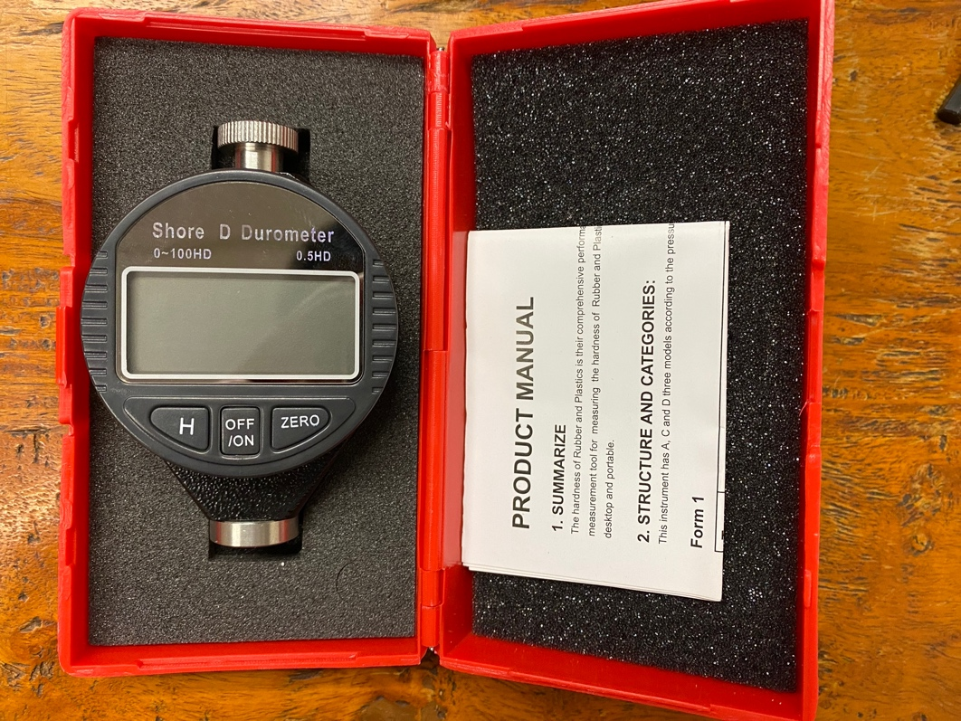
Figure 4: Durometer used for hardness testing
The procedure consists of puncturing the sample with the help of a durometer in order to get the hardness value of the samples. This puncturing process is performed three times on each different sample. Before the start of the test, the screen must show the value of zero to confirm the device is calibrated (if not, the “zero” button must be pushed to recalibrate the device). Initial hardness values of thermoplastic rings and rubber squares are given in Tables 2 and 3 respectively.

Table 2: Initial hardness value of thermoplastic rings
 | Hardness Values
Sample |  | Average
D1867 (ring 1) | 52 – 44 – 49 | 50
D1867 ( ring 2) | 51.5 – 40.5 – 41.5 | 44.5
D1868 (1) | 54 – 53 – 56.5 | 54.5
D1868 (2) | 46.5 – 49 – 43 | 46.16
D1869 (1) | 54 – 58.5 – 49.5 | 54
D1869 (2) | 50 – 54 – 49.5 | 51.16
D1870 (1) | 63.5 – 56.5 – 59.5 | 59.83
D1870 (2) | 59 – 57.5 – 59.5 | 58.66
D1872 (1) | 53 – 52.5 – 61.5 | 55.66
D1872 (2) | 62 – 58 – 53.5 | 57.83

Table 3: Initial hardness value of rubber squares
Square number | Hardness measured (before oven) | Average
1799/03 | 40 – 41 – 42 | 41
1787/03 | 42.5 – 40.5 – 40 | 41
1782/03 | 42.5 – 43 – 42.5 | 42.66
1788TH | 49 – 50 – 51 | 50

High temperatures testing

Thermoplastic rings
High-temperature conditions refer to placing one ring from each representative sample in the oven heated at high temperatures (475ºF – 650 ºF). Tests were conducted for seven cycles. Each cycle of the test consists of exposing the sample to high-temperature conditions for two weeks. After each cycle, the dimension and hardness of the samples were measured and compared with the labeled data provided by Welltec. Moreover, for better visualization of the temperature effects on the samples, pictures were captured from the microscope before and after the exposure to the high-temperature testing. The results of different test cycles on the thermoplastic rings are as follows:

First cycle
The first cycle test consisted of exposing the sample to 475 ºF for two weeks. The result after the first cycle is given in Tables 4 and 5, and in Figure 5.
Table 4: Dimension result of thermoplastic rings after the first cycle of exposure
Sample after heated up / 475ºF | Labeled dimensions provided by Welltec |  |  | Dimensions after exposure to 475ºF for two weeks
 | OD (mm) | ID (mm) | WT (mm) | OD (mm) | ID (mm) | WT (mm)
D1867 | 60 | 30 | 5 | 59.99 | 31 | 5.01
D1868 | 75 | 55 | 10 | 74.97 | 55.01 | 10
D1869 | 110 | 90 | 10 | 109.96 | 90.01 | 10.02
D1870 | 75 | 55 | 10 | 74.98 | 55.03 | 10
D1872 | 50 | 30 | 5 | 50.02 | 31.02 | 5.01

Table 5: Hardness result of thermoplastic rings after the first cycle of exposure
 | Hardness Values
Sample after heated up / 475ºF |  | Average
D1867 | 62.5 – 58 – 60 | 60.16
D1868 | 62 – 62 – 64 | 62.66
D1869 | 64 – 65 – 64 | 64.33
D1870 | 63 – 65 – 64 | 64
D1872 | 64.5 – 63.5 – 63.5 | 63.83

Sample No. | Pictures taken before exposure to the first cycle | Pictures taken after exposure to first cycle
D1867 | 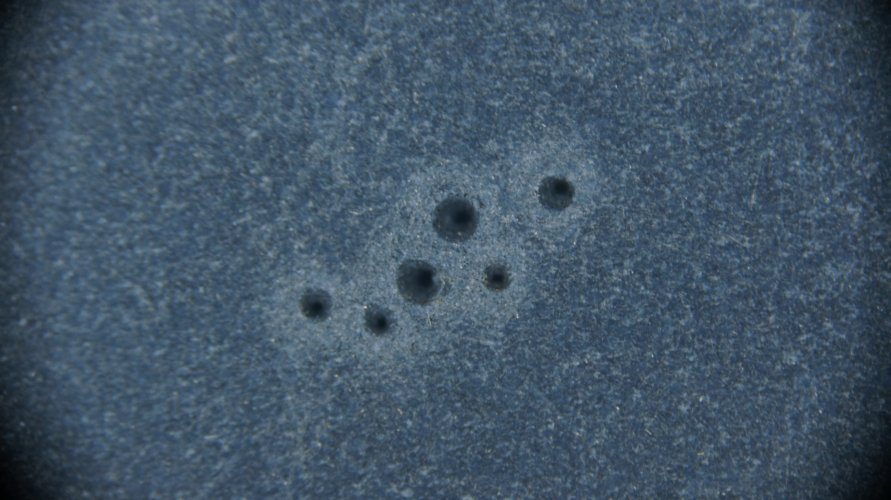 | 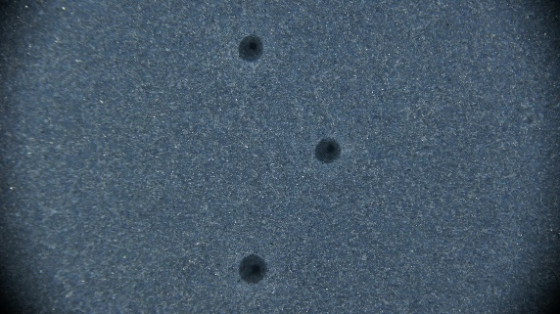
D1868 | 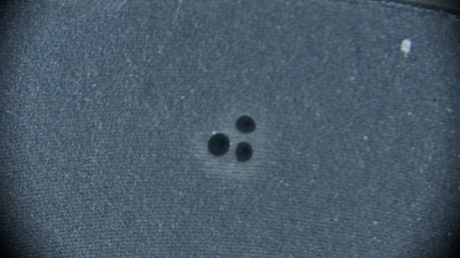 | 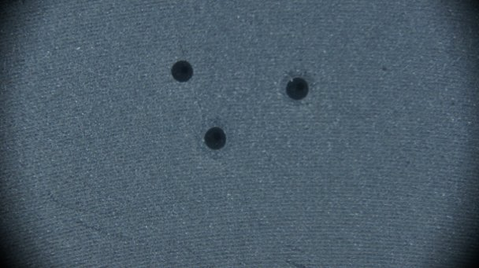
D1869 | 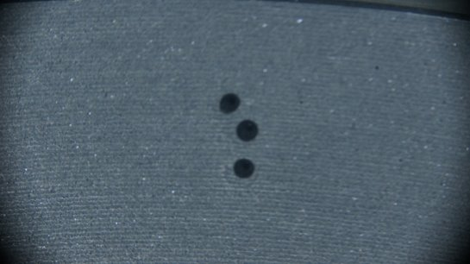 | 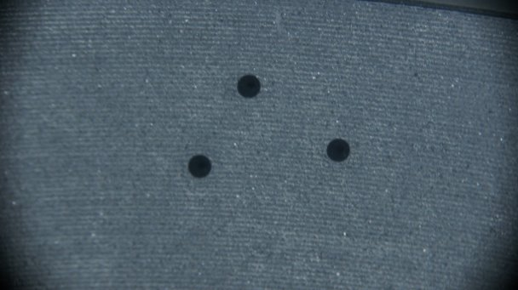
D1870 | 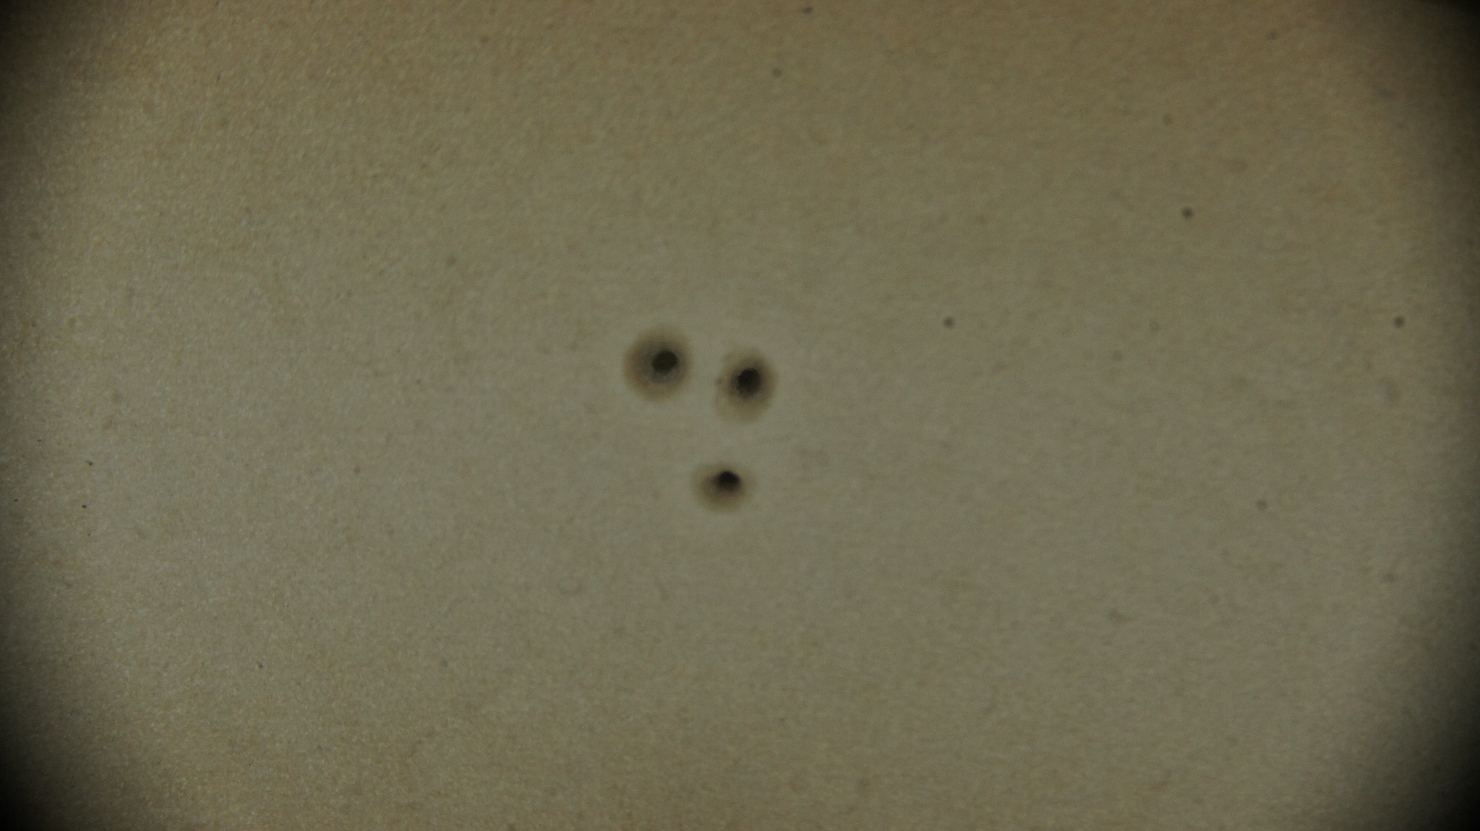 | 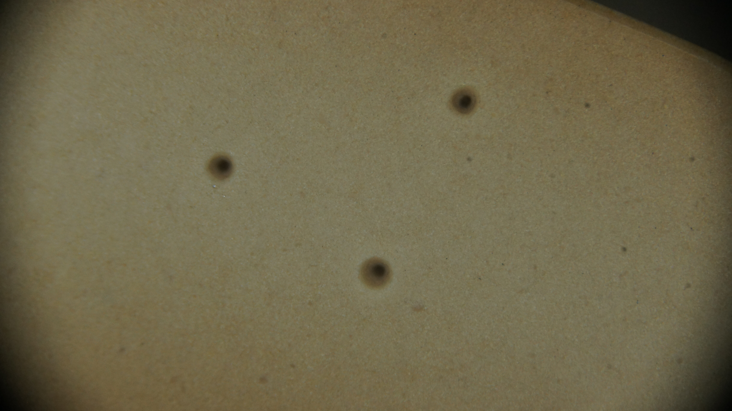
D1872 | 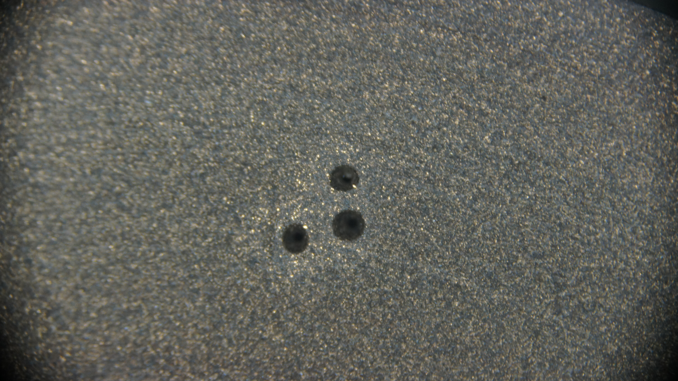 | 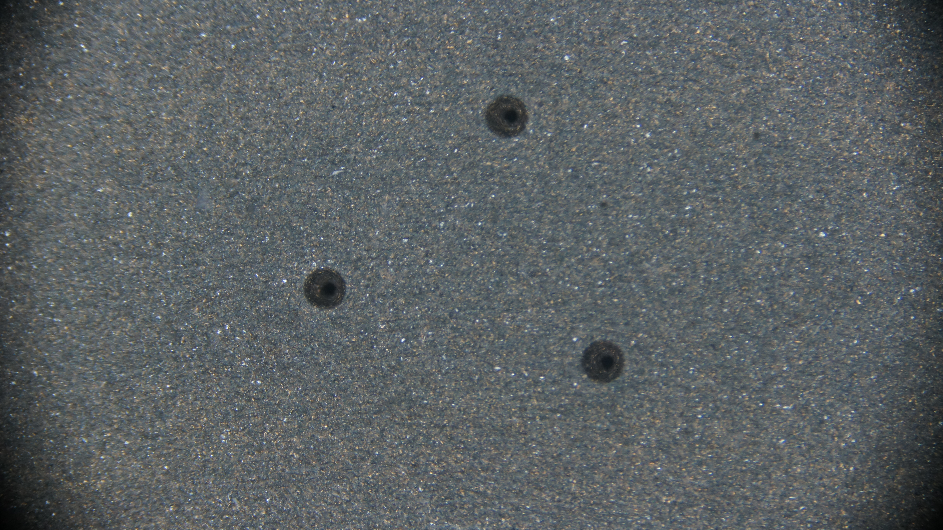
Figure 5: Picture of thermoplastic rings samples before and after exposure to the first cycle

Second cycle
The second cycle test consisted of placing the sample in the oven for two weeks at 475 ºF. The results of the second cycle test are given in the following tables and figure.
Table 6: Dimension result of thermoplastic rings after the second cycle of exposure
Sample after heated up (second time) / 475ºF | Labeled dimension provided by Welltec |  |  | Dimension after exposure to 475ºF for two weeks
 | OD (mm) | ID (mm) | WT (mm) | OD (mm) | ID (mm) | WT (mm)
D1867 | 60 | 30 | 5 | 59.99 | 30.98 | 5
D1868 | 75 | 55 | 10 | 74.97 | 55 | 10
D1869 | 110 | 90 | 10 | 109.99 | 90.02 | 10.03
D1870 | 75 | 55 | 10 | 74.96 | 54.98 | 10
D1872 | 50 | 30 | 5 | 50 | 31.01 | 5.01

Table 7: Hardness results of thermoplastic rings after the second cycle of exposure
 | Hardness Values
Sample after heated up (second time) / 475ºF |  | Average
D1867 | 60.5 – 62 – 60 | 60.83
D1868 | 64 – 62 – 61 | 62.33
D1869 | 68.5 – 68 – 67.5 | 68
D1870 | 63.5 – 65.5 – 65 | 64.66
D1872 | 65 – 65 – 65.5 | 65.16

Sample No. | Pictures taken before exposure to the first cycle | Pictures taken after exposure to the second cycle
D1867 |  | 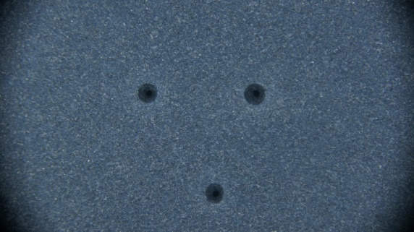
D1868 |  | 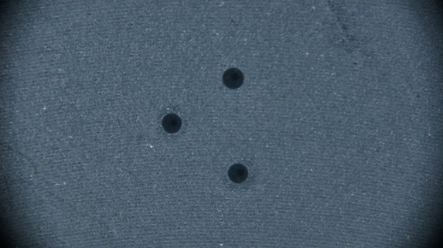
D1869 |  | 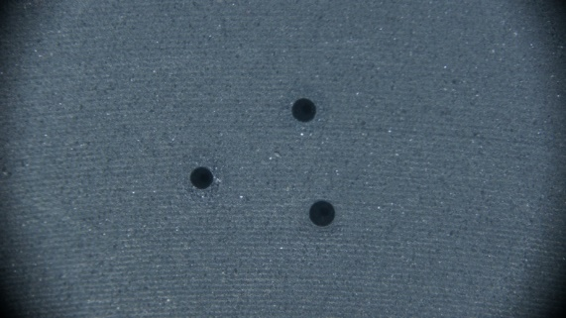
D1870 |  | 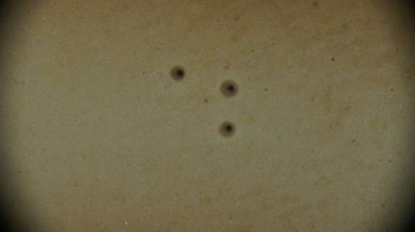
D1872 |  | 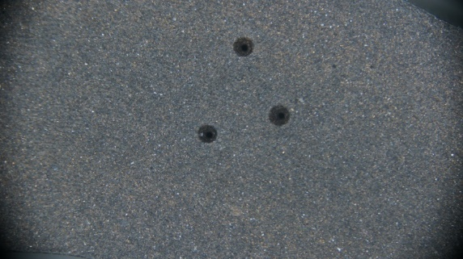
Figure 6: Picture of thermoplastic rings samples before and after exposure to the second cycle

Third cyclec
For the third cycle testing, the samples were exposed to 575 ºF in the oven for two weeks.
Table 8: Dimension results of thermoplastic rings after the third cycle of exposure
Sample after heated up (third time) / 575ºF | Labeled dimension provided by Welltec |  |  | Dimension after exposure to 575ºF for two weeks
 | OD  (mm) | ID (mm) | WT (mm) | OD (mm) | ID (mm) | WT (mm)
D1867 | 60 | 30 | 5 | 59.89 | 30.93 | 5.02
D1868 | 75 | 55 | 10 | 74.75 | 54.9 | 9.98
D1869 | 110 | 90 | 10 | 109.85 | 89.94 | 10
D1870 | 75 | 55 | 10 | 74.77 | 54.85 | 9.97
D1872 | 50 | 30 | 5 | 49.92 | 30.93 | 5.01

Table 9: Hardness results of thermoplastic rings after the third cycle of exposure
 | Hardness Values
Sample after heated up (third time) / 575ºF |  | Average
D1867 | 61.5 – 61 – 61 | 61.16
D1868 | 63.5 – 62 – 62.5 | 62.66
D1869 | 66.5 – 65.5 – 65.5 | 65.83
D1870 | 64.5 – 63.5 – 65 | 64.33
D872 | 64 – 64 – 64.5 | 64.16

Sample No. | Pictures taken before exposure to the first cycle | Pictures taken after exposure to the third cycle
D1867 |  | 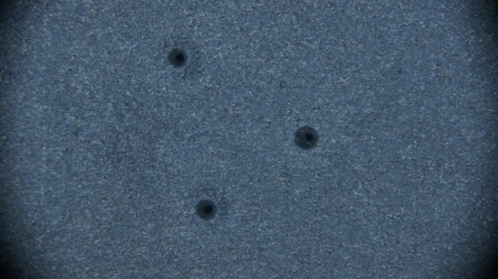
D1868 |  | 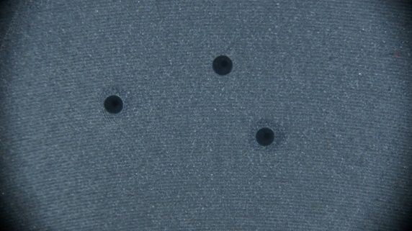
D1869 |  | 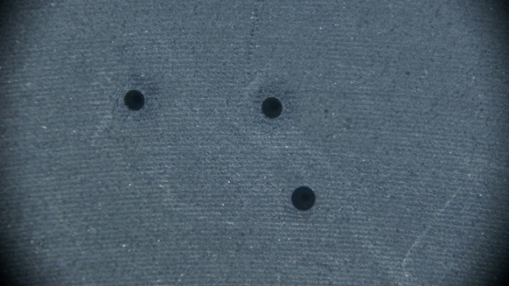
D1870 |  | 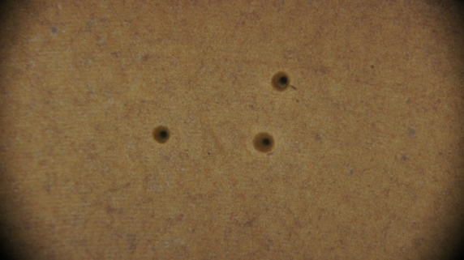
D1872 |  | 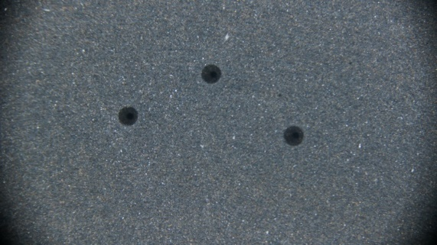
Figure 7: Picture of thermoplastic rings samples after exposure to the third cycle

Fourth cycle
Data collected after rings were placed at high temperature (575 ºF) in the oven for two weeks. Table 10, 11, and Figure 8 shows the result of the fourth cycle.
Table 10: Dimension result of thermoplastic rings after the fourth cycle of exposure
Sample after heated up (fourth time) / 575ºF | Labeled dimension provided by Welltec |  |  | Dimension after exposure to 575ºF for two weeks
 | OD (mm) | ID (mm) | WT (mm) | OD (mm) | ID (mm) | WT (mm)
D1867 | 60 | 30 | 5 | 59.89 | 30.93 | 5.06
D1868 | 75 | 55 | 10 | 74.76 | 54.88 | 9.99
D1869 | 110 | 90 | 10 | 109.89 | 89.93 | 10
D1870 | 75 | 55 | 10 | 74.65 | 54.83 | 9.98
D1872 | 50 | 30 | 5 | 49.98 | 30.99 | 5

Table 11: Hardness result of thermoplastic rings after the fourth cycle of exposure
 | Hardness Values
Sample after heated up (fourth time) / 575ºF |  | Average
D1867 | 61– 62 – 60 | 61
D1868 | 66 – 67 – 65.5 | 66.16
D1869 | 66 – 65.5 – 67 | 66.16
D1870 | 63 – 63 – 64 | 63.33
D1872 | 62 – 64.5 – 64.5 | 63.66

Sample No. | Pictures taken before exposure to the first cycle | Pictures taken after exposure to the fourth cycle
D1867 |  | 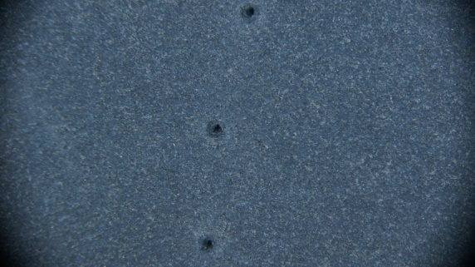
D1868 |  | 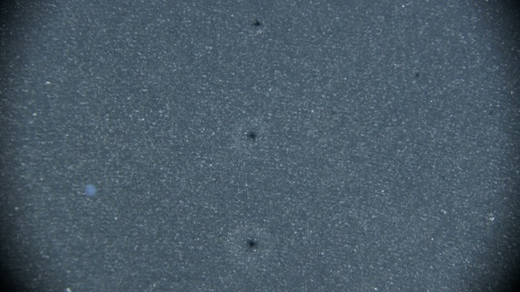
D1869 |  | 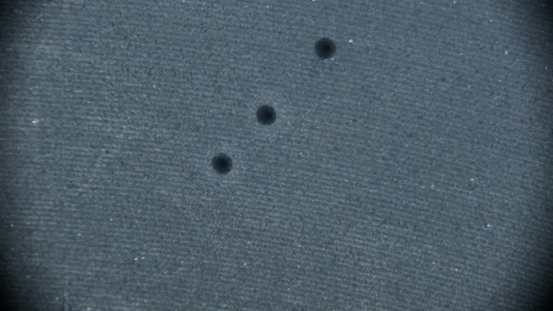
D1870

D1872 |  | 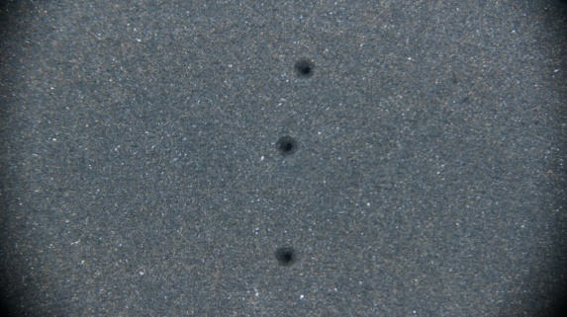
Figure 8: Picture of thermoplastic rings samples after exposure to the fourth cycle

Fifth cycle
In the fifth cycle, the temperature of the oven was further increased to 650 ºF. The results of the fifth cycle are given in the following tables and figure.
Table 12: Dimension result of thermoplastic rings after the fifth cycle of exposure
Sample after heated up (fifth time) / 650ºF | Labeled dimension provided by Welltec |  |  | Dimension after exposure to 650ºF for two weeks
 | OD (mm) | ID (mm) | WT (mm) | OD (mm) | ID (mm) | WT (mm)
D1867 | 60 | 30 | 5 | 59.82 | 30.9 | 5.02
D1868 | 75 | 55 | 10 | 73.25 | 53.59 | 10.17
D1869 | 110 | 90 | 10 | 109.84 | 89.77 | 10.03
D1870 | 75 | 55 | 10 | 72.01 | 53.3 | 9.75
D1872 | 50 | 30 | 5 | 50.85 | 31.71 | 5.2

Table 13: Hardness result of thermoplastic rings after the fifth cycle of exposure
 | Hardness Values
Sample after heated up (fifth time) / 650ºF |  | Average
D1867 | 64.5– 64.5 – 64.5 | 64.5
D1868 | 61 – 62.5 – 60.5 | 61.33
D1869 | 64.5 – 64.5 – 60 | 63
D1870 | 59 – 58 – 57 | 58
D1872 | 65.5 – 64 – 64.5 | 64.66

Sample No. | Pictures taken before exposure to the first cycle | Pictures taken after exposure to fifth cycle
D1867 |  | 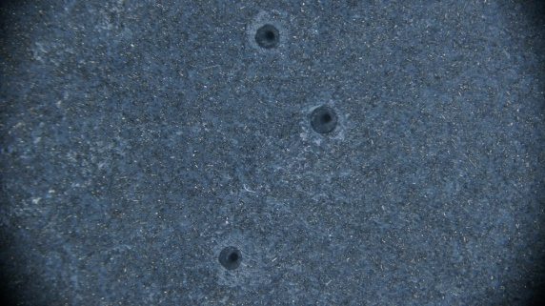
D1868 |  | 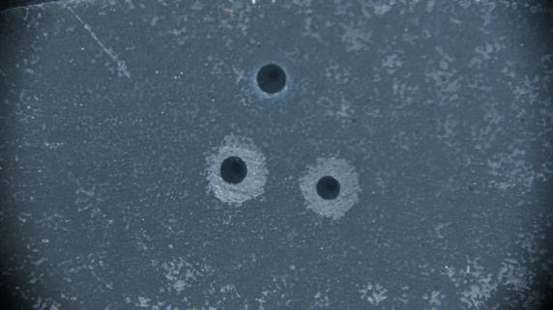
D1869 |  | 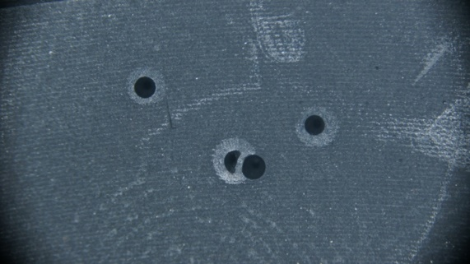
D1870 |  | 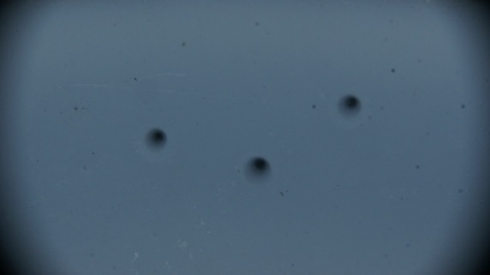
D1872 |  | 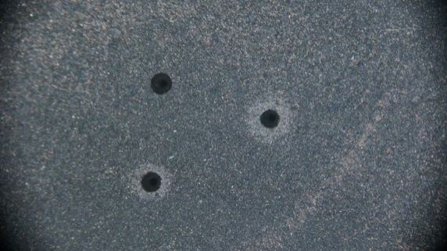
Figure 9: Picture of thermoplastic rings samples after exposure to the fifth cycle

Sixth cycle
The sixth cycle consisted of the sample being placed at 475ºF in the oven for two weeks. The results are given in Tables 14 and 15, and Figure 10.
Table 14: Dimension result of thermoplastic rings after the sixth cycle of exposure
Sample after heated up (sixth time) / 475ºF | Labeled dimension provided by Welltec |  |  | Dimension after exposure to 475ºF for two weeks
 | OD (mm) | ID (mm) | WT (mm) | OD (mm) | ID (mm) | WT (mm)
D1867 | 60 | 30 | 5 | 59.75 | 30.8 | 4.99
D1868 | 75 | 55 | 10 | 73.2 | 53.4 | 10.13
D1869 | 110 | 90 | 10 | 107.79 | 89.54 | 9.9
D1870 | 75 | 55 | 10 | 71.85 | 52.85 | 9.67
D1872 | 50 | 30 | 5 | 50.8 | 31.96 | 5.2

Table 15: Hardness result of thermoplastic rings after the sixth cycle of exposure
 | Hardness Values
Sample after heated up (sixth time) / 475ºF |  | Average
D1867 | 64.5– 64.5 – 65 | 64.66
D1868 | 60.5 – 62.5 – 60.5 | 61.16
D1869 | 62.5 – 64.5 – 61.5 | 62.83
D1870 | 60 – 58 – 60.5 | 59.5
D1872 | 65.5 – 65 – 66 | 65.5

Sample No. | Pictures taken before exposure to the first cycle | Pictures taken after exposure to sixth cycle
D1867 |  | 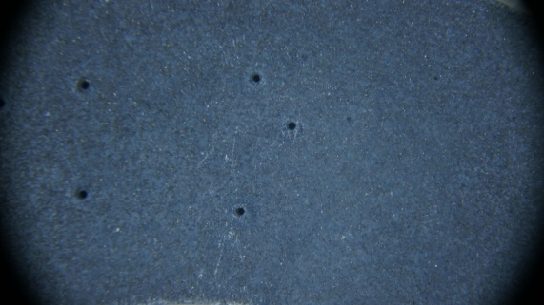
D1868 |  | 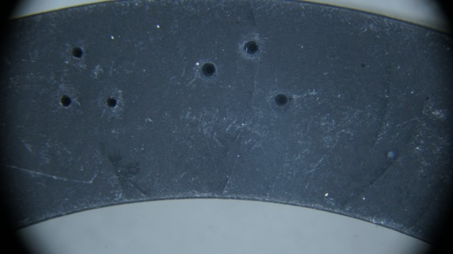
D1869 |  | 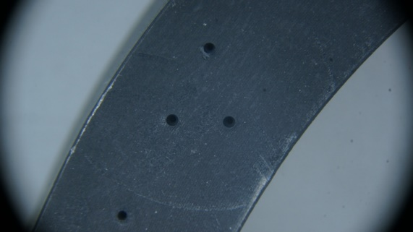
D1870 |  | 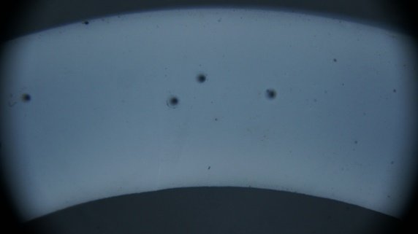
D1872 |  | 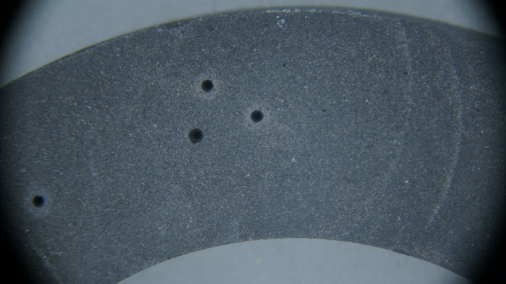
Figure 10: Picture of samples after the exposure to sixth cycle

Seventh Cycle
In this cycle the thermoplastic rings were exposed to 475°F again for two weeks and the measurements were made after the test that can be seen in Tables 16, 17 and Figure 11. After the exposure to the temperature test, it was found that the sample D1869 had different wall thickness in one of the points in the circumference.

Table 16: Dimension result of thermoplastic rings after the seventh cycle of exposure
Sample after heated up (seventh time) / 475ºF | Labeled dimension provided by Welltec |  |  | Dimension after exposure to 475ºF for two weeks
 | OD (mm) | ID (mm) | WT (mm) | OD | ID | WT (mm)
D1867 | 60 | 30 | 5 | 59.66 | 30.8 | 4.99
D1868 | 75 | 55 | 10 | 72.85 | 53.5 | 10.14
D1869 | 110 | 90 | 10 | 108.31 | 88.35 | 9.94*
D1870 | 75 | 55 | 10 | 71.71 | 52.85 | 9.66
D1872 | 50 | 30 | 5 | 50.77 | 32.1 | 5.18

* In addition to this value, there was a point on the ring that had a different wall thickness of 10.32mm

Table 17: Hardness result of thermoplastic rings after the seventh cycle of exposure
Sample after heated up (seventh time) / 475ºF | Hardness Values
 |  | Average
D1867 | 64.5– 64 – 65 | 64.5
D1868 | 58 – 61 – 60 | 59.667
D1869 | 65.5 – 65 – 64.5 | 65*
D1870 | 61 – 58 – 60.5 | 59.833
D1872 | 65.5 – 67 – 67 | 66.5

* In addition to this value, zone of the ring that had a different wall thickness had a different hardness whose values were 56 – 55 – 59 having average of 56.667.

Sample No. | Pictures taken before exposure to the first cycle | Pictures taken after exposure to seventh cycle
D1867 |  | 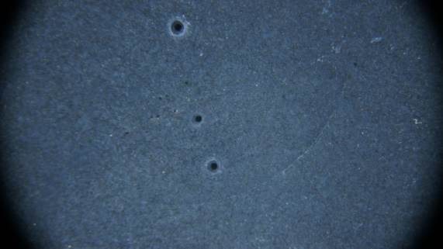
D1868 |  | 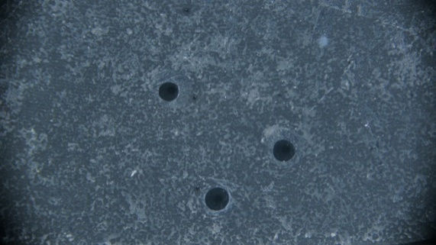
D1869 |  | 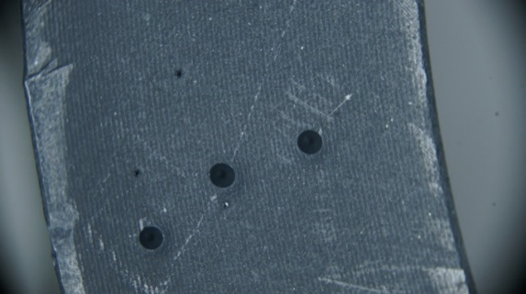
D1870 |  | 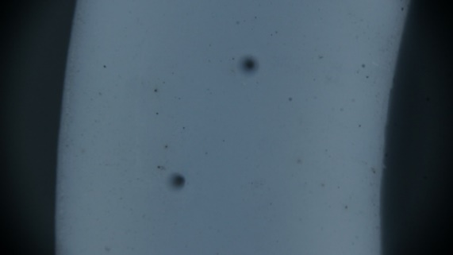
D1872 |  | 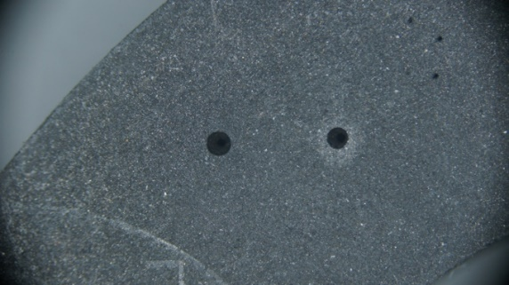
Figure 11: Picture of samples after the exposure to seventh cycle

Comparison of results of thermoplastic rings
In the following figures comparison of dimensional (OD, ID, and WT) and hardness result between the different cycle and initial condition of the thermoplastic rings are given

Dimensions

Figure 12: Dimensions comparison of sample D1867 when exposed to seven cycles of temperature testing

Figure 13: Dimensions comparison of sample D1868 when exposed to seven cycles of temperature testing

Figure 14: Dimensions comparison of sample D1869 when exposed to seven cycles of temperature testing

Figure 15: Dimensions comparison of sample D1870 when exposed to seven cycles of temperature testing

Figure 16: Dimensions comparison of sample D1872 when exposed to seven cycles of temperature testing

Hardness
In the following table and figures, hardness comparison of the samples when exposed to different temperature cycle is shown
Table 18: Legend description for Figures 17 to 20
Material No. | Sample No
1 | D1867
2 | D1868
3 | D1869
4 | D1870
5 | D1872

Figure 17: Samples hardness after first and second cycle of exposure at 475°F

Figure 18: Samples hardness after third and fourth cycle of exposure at 575°F

Figure 19: Samples hardness after fifth cycle of exposure at 650°F

Figure 20: Samples hardness after sixth and seventh cycle of exposure at 475°F

Figure 21: Hardness comparison of sample D1867 when exposed to seven cycles of temperature testing

Figure 22: Hardness comparison of sample D1868 when exposed to seven cycles of temperature testing

Figure 23: Hardness comparison of sample D1869 when exposed to seven cycles of temperature testing
It must be noted that after the seventh cycle of exposure sample D1869 showed two different hardness because it had different wall thickness

Figure 24: Hardness comparison of sample D1870 when exposed to seven cycles of temperature testing

Figure 25: Hardness comparison of sample D1872 when exposed to seven cycles of temperature testing

Anomaly in the sample D1870
A special set of tests were done in the sample with D1870 because the sample had totally changed in color after seven cycles of testing. The ring was divided in eight sections (Figure 26), the wall thickness and hardness was measured and is shown in the following Figures.

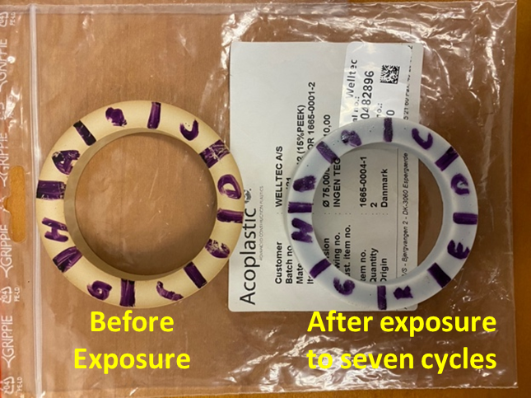
Figure 26: Sample D1870 divided into eight sections

Table 19: Section measurements of sample D1870
D1870 BEFORE EXPOSURE TO HT |  |  |  |  | D1870 AFTER EXPOSURE TO HT IN SEVEN CYCLES
Couple Sections | OD (mm) | ID (mm) | Section | WT (mm) | Couple Sections | OD (mm) | ID (mm) | Section | WT (mm)
AE | 74.95 | 54.95 | A | 9.99 | AE | 71.61 | 52.78 | A | 9.67
BF | 74.96 | 54.96 | B | 10 | BF | 71.75 | 52.8 | B | 9.67
CG | 74.97 | 55.02 | C | 9.99 | CG | 71.71 | 52.95 | C | 9.69
DH | 74.99 | 55.03 | D | 9.99 | DH | 71.78 | 52.90 | D | 9.69
 |  |  | E | 9.98 |  |  |  | E | 9.68
 |  |  | F | 9.97 |  |  |  | F | 9.63
 |  |  | G | 9.98 |  |  |  | G | 9.63
 |  |  | H | 9.98 |  |  |  | H | 9.66

Figure 27:Dimesion measurement comparison of different sections of sample D1870

Figure 28: Hardness measurement comparison of different sections of sample D1870

Finding of thermoplastic rings
Following changes in the thermoplastic ring were observed after being exposed to high temperatures for seven-time:
- The hardness of the material increases during the different temperature cycle testing
- The color of the specimen changed, especially for D1870 the color was transformed from brown to white as shown in Figure 26
- The rings lose their shapes and shift from circle to oval. In that respect, sample 1869 showed a prominent change in the shape transformation
- The dimension of the samples was changed and shrunk to a few millimeters after multiple exposures to high-temperature conditions

Rubber squares testing.
For the rubber squares, two cycle of temperature testing was conducted at 475°F. In which each cycle represents the exposure of rubber square samples for two weeks at the given temperature. After every cycle of exposure to high temperature, the hardness and dimension test was performed, and pictures were captured from the microscope.

First cycle
In this cycle, the rubber square samples were exposed to 475°F for the time period of two weeks. The results from this cycle are shown in Figure 30 and Table 20.
Table 20: Hardness results of rubber square sample after being exposed to 475F for two weeks
Material No. | Square number | Hardness measured after oven (475 ºF) | Average
1 | 1799/03 | 47.5 – 49 – 52 | 49.5
2 | 1787/03 | 56 – 57.5 – 55.5 | 56.33
3 | 1782/03 | 54.5 – 53 – 56 | 54.5
4 | 1788TH | 59.5 – 60 – 59.5 | 59.66

Figure 29: Hardness comparison of rubber square after being exposed to 475°F for two weeks

Sample No. | Pictures taken before exposure to the first cycle | Pictures taken after exposure to first cycle
1799/03 |  | 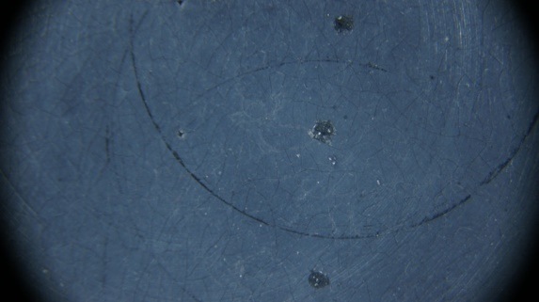
1787/03 | 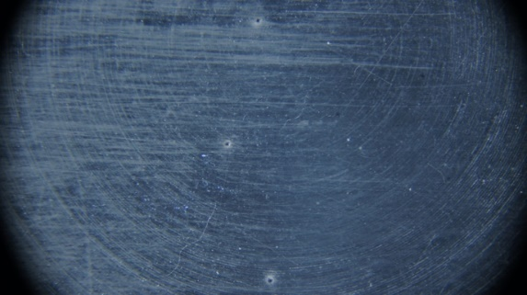 | 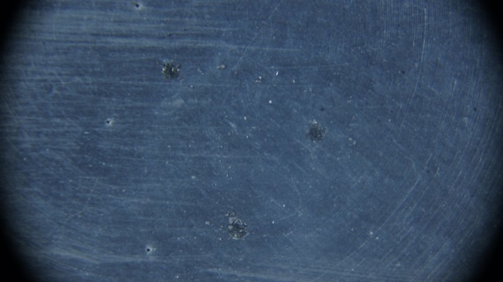
1782/03 |  | 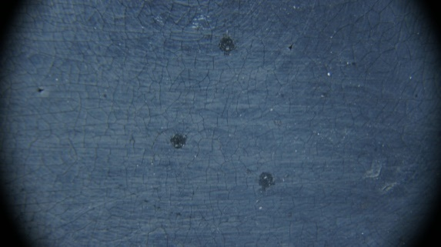
1788TH | 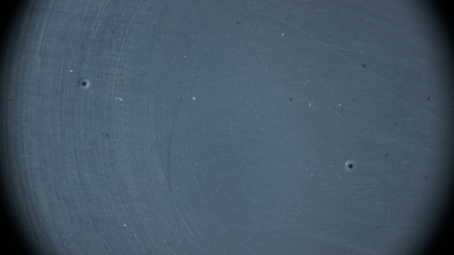 | 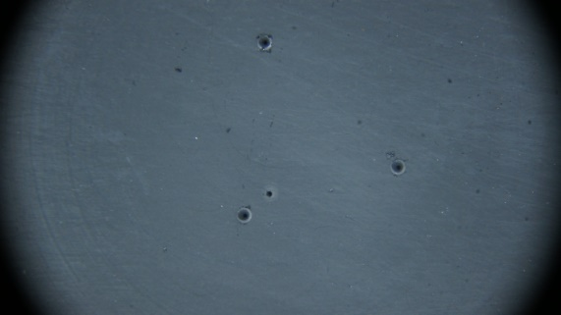
Figure 30: Picture of rubber square samples after the exposure to first cycle

It is important to mention that after the first cycle, the material labeled as1782/03 suffered severe damage as shown in Figure 31.

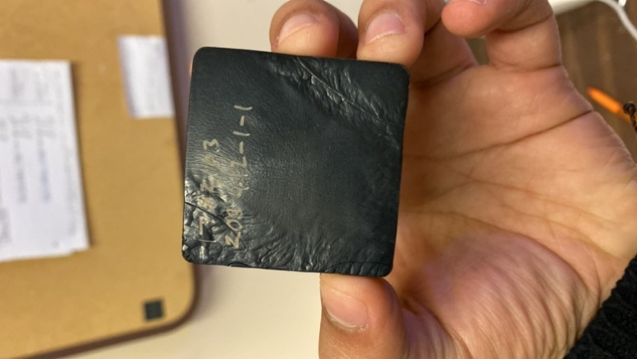
Figure 31: Severe damage to rubber square 1782/03

Second cycle
For the second cycle the rubber square samples were again exposed to 475°F after which the dimension and hardness test along with the pictures were taken and is represented in Tables 21, 22 and Figure 33. It was seen that sample 1782/03 which was already damaged during the first cycle was completely broken during the hardness test that was conducted after the second cycle (Figure 32).
Figure 32: Broken sample 1782/03

Square number | Dimensions before exposure (room temperature) (mm) | WT (mm) | Dimensions after second exposure to 475 ºF (mm) | WT (mm)
1799/03 | 49.65 x 49.49 | 6.3 | 49.02 x 48.81 | 6.02
1787/03 | 49.29 x 49.30 | 6.47 | 48.41 x 48.37 | 6.24
1782/03 | 49.29 x 49.44 | 6.4 | Sample was broken
1788TH | 49.83 x 49.84 | 6.31 | 49.45 x 49.55 | 5.96
Table 21:Dimession results of rubber square sample after being exposed to 475°F for two weeks in second cycle

Table 22: Hardness results of rubber square sample after being exposed to 475°F for two weeks in second cycle
Square number | Hardness measured (before oven) | Average | Hardness measured after oven (475 ºF) | Average | Hardness measured after second time in oven (475 ºF) | Average
1799/03 | 40 – 41 – 42 | 41 | 47.5 – 49 – 52 | 49.5 | 50.5 – 50 – 51 | 50.5
1787/03 | 42.5 – 40.5 – 40 | 41 | 56 – 57.5 – 55.5 | 56.33 | 57 – 57.5 – 55 | 56.5
1782/03 | 42.5 – 43 – 42.5 | 42.66 | 54.5 – 53 – 56 | 54.5 | Sample broken
1788TH | 49 – 50 – 51 | 50 | 59.5 – 60 – 59.5 | 59.66 | 62.5 – 62.5 – 62.5 | 62.5

Sample No. | Pictures taken before exposure to the first cycle | Pictures taken after exposure to second cycle
1799/03 |  | 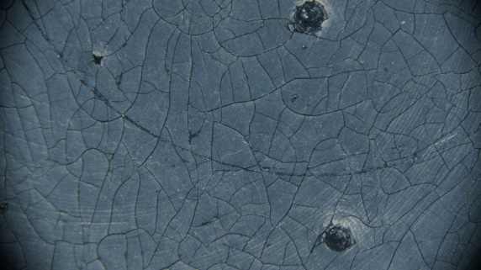
1787/03 |  | 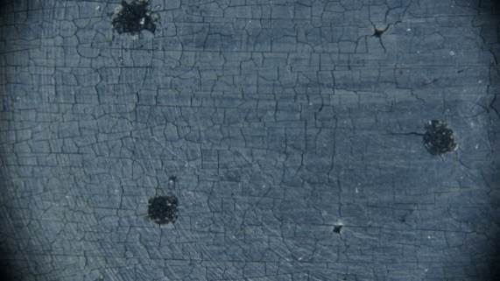
1782/03 |  | No microscopic picture taken (Sample Broken)
1788TH |  | 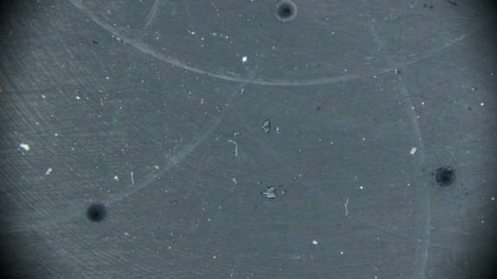
Figure 33: Picture of rubber square samples after the exposure to second cycle

Comparison of results of rubber square
In the following figures comparison of the rubber square before and after the exposure to temperature cycle is shown. It should be noted that the sample 1782/03 was broken during the hardness test, therefore, its reading will be missing in the figures 34, 35 and 36.

Dimensions

Figure 34:Comparison of wall thickness between before and after the exposure to second cycle

Figure 35: Comparison of rubber square perimeter between before and after the exposure to second cycle

Hardness

Figure 36: Comparison of rubber square hardness between before and after the exposure to first and second cycle

Thermal properties
Thermal properties testing was performed on the rubber square samples with the help of Keithley 2400 meter with TPS-3 (Figure 37). The equipment has the capability to measure thermal conductivity, heat capacity, diffusivity, and effusivity. The measurement is taken in such a way that the sensor is place between the two same sample and the equipment is run. In the first set of tests the reading was taken on the samples that were not exposed to high temperature condition. Whereas for the second set of tests, one sample of rubber square from the representative same was taken after the second cycle exposure and the other sample was the one that was not exposed to the thermal loading. The results are shown in Table 23 and 24.

Figure 37: Keithley 2400 meter with TPS-3 for the measurement of thermal properties

Table 23: Thermal properties of rubber square samples that were not exposed to high temperature condition
Sample No. | Thermal conductivity (W/mK) | Diffusivity (mm²/s) | Heat Capacity (MJ/m³K) | Effusivity  (W√s/(m²K))
1799/03 | 0.380 | 0.271 | 1.403 | 730.092
1787/03 | 0.333 | 0.183 | 1.189 | 777.650
1782/03 | 0.366 | 0.221 | 1.815 | 803.49
1788TH | 0.263 | 0.124 | 2.126 | 747.09

Table 24: Thermal properties of rubber square sample in which one sample was taken after second cycle test and the other one was not exposed to high temperature condition
Sample No. | Thermal conductivity (W/mK) | Diffusivity (mm²/s) | Heat Capacity (MJ/m³K) | Effusivity  (W√s/(m²K))
1799/03 | 0.346 | 0.225 | 1.535 | 728.787
1787/03 | 0.318 | 0.170 | 1.880 | 773.315
1782/03 | The sample broke down after the second cycle exposure
1788TH | 0.279 | 0.146 | 1.912 | 729.601

Figure 38: Comparison of thermal properties of initial and second cycle of rubber square

Figure 39: Comparison of effusivity of initial and second cycle of rubber square

It can be noted form the above figures that the thermal properties of rubber squares decreased after the exposure to second cycle.

